**MINI PROJECT**

**(2020-2021)**

**Secure E-Learning Chat Application**

**MID-TERM REPORT**



**Institute Of Engineering and Technology**

**Team Members**

Shalini Kumari

(181500649)

Ritik Srivastava

(181500578)

Adarsh Kumar

(181500037)

Shashank Agrawal

(181500652)

Vanshika Agrawal

(181500780)

**-Supervised By**

**Name- Mr. Amit Kumar Chaudhary**

**Training and Placement Dept.**

**Department of Computer Engineering & Applications**

**CONTENT**

**Abstract**

1. **Introduction**

1.1 General Introduction to the topic

1.2 How does online chat works?

1.3 Hardware and Software Requirements

1. **Problem definition**
2. **Objectives**
3. **Implementation Details**
4. **Progress till Date & The Remaining work**
5. **Some Screenshots**
6. **ER Diagram**
7. **Data Flow Diagram**
8. **References**

**Abstract of the project e-chat Application:**

The purpose of e-chat Application is to automate the existing manual system by the help of computerized equipment’s and full-fledged computer software, fulfilling their requirements, so that their valuable data/information can be stored for a longer period with easy accessing and manipulation of the same. The software and hardware are easily available and easy to work with.

E-chat Application, can lead to error free, secure, reliable and fast management system. It can assist the user to concentrate on their other activities rather to concentrate on the recording keeping. Thus it will help organization can maintain computerized records without redundant entries. That means that one need not be distracted by information that is not relevant, while being able to reach the information.

The aim is to automate its existing manual system by the help of computerized equipment and full-fledged computer software, fulfilling their requirement, so that their valuable data/information can be stored for a longer period with easy accessing and manipulation of the same. Basically the project describe how to manage for good performance and better services for clients.

**Introduction to e-chat Application:**



Online e-chat application is a form of communication that utilizes computer programs that allow for two-way conversations between users in real time (events that occur in cyberspace at the same speed that they would occur in real life).

Typically the users will connect to a chat server using a chat client and meet in a chat room. Once the users are in the same chat room, they can converse with one another by typing messages into a window where all of the other users in the chat room can see the message. The user can also see all of the messages entered by the other users. Conversations are then carried on by reading the messages entered by the other users in the chat room and responding to them.

**How does online chat work?**

The technologies that allows users to converse in real time via typed messages are the chat servers and the chat clients. These special servers allow the messages to be quickly received and posted so that the chat clients can receive the messages and display them in the window on the users' computers. Fortunately, most chat clients are relatively inexpensive shareware programs, and there are a number of chat servers that let the user connect to them for free. Online chat could be an alternative to meeting in a traditional classroom. While all of the participants would still be able to freely converse with one another, they would carrying on the conversation from the comfort of their own home, thus avoiding the expense and inconvenience of traveling to another place.

**Problem Statement:**

As we all know about the current pandemic situation due to COVID-19, because of which we all are locked at our homes for so many months and don't know what future situation will be. Especially for students, this situation seems very difficult to handle.

So many students are slowly developing big confusions and distractions in their brains. But many are doing e-learning courses and online classes to develop their skills, but then also there are many questions that are always inside them and they don’t have anyone to guide them. So, to clear all these questions and put their cars back on track our app can really help. This app will connect students directly with the teachers of their fields and will help them to solve their queries.

**Reason:**

In the past few years, chat rooms have become a popular way to support a forum for n-way conversation or discussion among a set of people with interest in a common topic. Chat applications range from simple, text-based ones to entire virtual worlds with exotic graphics. But also, many of us still have many questions in our brains.

The reasons behind this maybe are:

1. There is no authority to check the mentors' guidance.
2. They have to rely only on their faculty and their guidance.
3. Delay in the response due to a bunch of emails to be filtered by them to give any reply to anyone.
4. The questions can be missed out by the faculty due to a lot of messages.
5. Fail to recall the consultation after a respective time.

So by taking all these points under consideration we proposed to build a project which can solve these issues, like:

1. If a reply is not given within an allotted time the ranking of the teacher will decrease.
2. Huge and the wide network is created by this app having all university teachers on a single platform.

**Objective:**

The main objective of the project is to make an E-learning chat mobile application at the university level where queries of students could be solved by teachers which can be achieved by the following:

* + Login by University E-mail Id.
  + Verifying teachers.
  + Creating a chat-box.

**Future Scope:**

The application can be extended to cover a wide range of intra-organizational as well as extra-organizational issues. Apart from doubt sessions related to studies, other areas like management and mental wellness could also be touched upon.

It could evolve as a single platform for knowledge sharing within an organization.  Content moderation can be done using the sentimental analysis to ensure the code of conduct. Extending it to Web Support.

**Requirements:**

1. Hardware:

Ram required- 8GB or above

Processor- core i5 or above

1. Software:

Linux or Windows Operating System

Android Studio or Vs-code

Android or IOS Emulator or Physical Smartphone.

1. Technology Used:

Flutter 1.20

Dart Programming Language

Firebase

**Methodology:**

The idea of this methodology is to develop an e-Learning system that favours the competitive position of the organization that uses it and is adaptable to suit the student’s needs. It refers to the mode and manner in which they produce the content that will be used in training.

In this application students and the faculty can sign up using their university email id and help each other to solve the queries they have. Students can broadcast or can directly message to a particular faculty for their queries. Students can also tag their messages to a particular faculty or experts in that field. To differentiate between students and faculty we will provide verified tags to the faculty using this application and for that, the faculty just have to make a request on the verification request tab.

**Modules: Description:**

|  |  |
| --- | --- |
| Login/Sign Up Screen | Users can sign up with their university email id and specify their role as student or faculty. |
| Contact Screen | Users can see the list of contacts they messaged previously or got a message from. |
| Chat Screen | Users can see the chats/messages they send or receive. |
| User Profile Screen | Users can see their information here. |
| Verification Screen | Faculty can send a verification request from this page. |
| Feedback Screen | The students can give their feedback or any suggestion regarding any topic. |

**Testing:**

The Flutter framework provides comprehensive support for Flutter automated testing of mobile apps. Manually testing mobile apps can be hard, especially if your app has many features. Automated tests help to ensure that your app performs correctly before you publish it while maintaining your feature and bug-fix velocity.

Automated testing falls into a few categories:

* + A unit testing tests a single function, method, or class.
  + A widget test (in other UI frameworks referred to as component test) tests a single widget.
  + An Integration Test tests a complete app or a large part of an app.

**Contributions:**

Today people know how to use smart devices and these devices are a huge part of their life. Hence, no time is better than now to introduce this technology (educational mobile app) via their mobile devices.

These mobile learning platforms are very appealing and will have the total attention of the learners.

E-learning is a new education concept by using internet technology, it delivers the digital content, provides a learner-orient environment for the teachers and students. E-learning promotes the construction of life-long learning opinions and learning society

.

E-Learning has completely transformed the way in which learning is imparted to students. Unlike traditional chalk and board methods of teaching, e-learning makes learning simpler, easier, and more effective.

E-Learning mobile app allows users to learn by using podcasts, videos and other mechanisms on their smartphone. Hence, they make the process of learning quite flexible for learners.

E-Learning mobile app allows the student to directly be in touch with the subject professors. Hence they can clear their doubts quickly. Often students suffer from lack of collaboration, however, these mobile learning apps offer them collaborative learning via online learning community app.

E-learning app ensure higher engagement, as learning is easily accessible by the students at any time and any place. One of the best benefits of e-learning is multi-device support.

**Progress till date and some screenshot:**

Welcome Screen

1. import 'package:comperio/constants.dart';
2. import 'package:comperio/screen/login_screen.dart';
3. import 'package:comperio/screen/registration_screen.dart';
4. import 'package:comperio/welcome_screen_button.dart';
5. import 'package:flutter/material.dart';
6. class WelcomeScreen extends StatefulWidget {
7. final String id = 'WelcomeScreen';
8. @override
9. _WelcomeScreenState createState() => _WelcomeScreenState();
10. }
11. class _WelcomeScreenState extends State<WelcomeScreen>
12. with SingleTickerProviderStateMixin {
13. AnimationController controller;
14. @override
15. void initState() {
16. super.initState();
17. controller = AnimationController(
18. duration: Duration(seconds: 3),
19. vsync: this.
20. );
21. controller.forward();
22. controller.addListener(() {
23. setState(() {});
24. });
25. }
26. @override
27. void dispose() {
28. controller.dispose();
29. super.dispose();
30. }
31. @override
32. Widget build(BuildContext context) {
33. return Container(
34. decoration: BoxDecoration(
35. color:Colors.white,
36. image: DecorationImage(
37. image: AssetImage('images/WelcomeScreen3.jpg'),
38. fit: BoxFit.cover,
39. ),
40. ),
41. constraints: BoxConstraints.expand(),
42. child: Scaffold(
43. backgroundColor: Colors.transparent,
44. body: Container(
45. child: Column(
46. mainAxisAlignment: MainAxisAlignment.spaceEvenly,
47. children: <Widget>[
48. Container(
49. padding: EdgeInsets.only(left: 30.0, right: 30.0),
50. child: Column(
51. children: <Widget>[
52. Hero(
53. tag: 'logo',
54. child: Container(
55. height: controller.value * 100,
56. child: Image(
57. image: AssetImage(
58. 'images/comperio-logo.png',
59. ),
60. height: 110.0,
61. width: 110.0,
62. ),
63. ),
64. ),
65. SizedBox(
66. height: 30.0,
67. ),
68. Center(
69. child: Text(
70. 'Welcome to',
71. style: KWelcomeTextStyle,
72. ),
73. ),
74. Center(
75. child: Text(
76. 'Comperio!',
77. style: KWelcomeTextStyle,
78. ),
79. ),
80. SizedBox(
81. height: 90.0,
82. ),
83. WelcomeScreenButtons(
84. buttonText: 'Login',
85. redirectionScreen: LoginScreen().id,
86. colour: Colors.blue,
87. ),
88. SizedBox(
89. height: 30.0,
90. ),
91. WelcomeScreenButtons(
92. buttonText: 'Register',
93. redirectionScreen: RegistrationScreen().id,
94. colour: Color(0xff311b92)
95. ),
96. ],
97. ),
98. ),
99. ],
100. ),
101. ),
102. ),
103. );
104. }
105. }

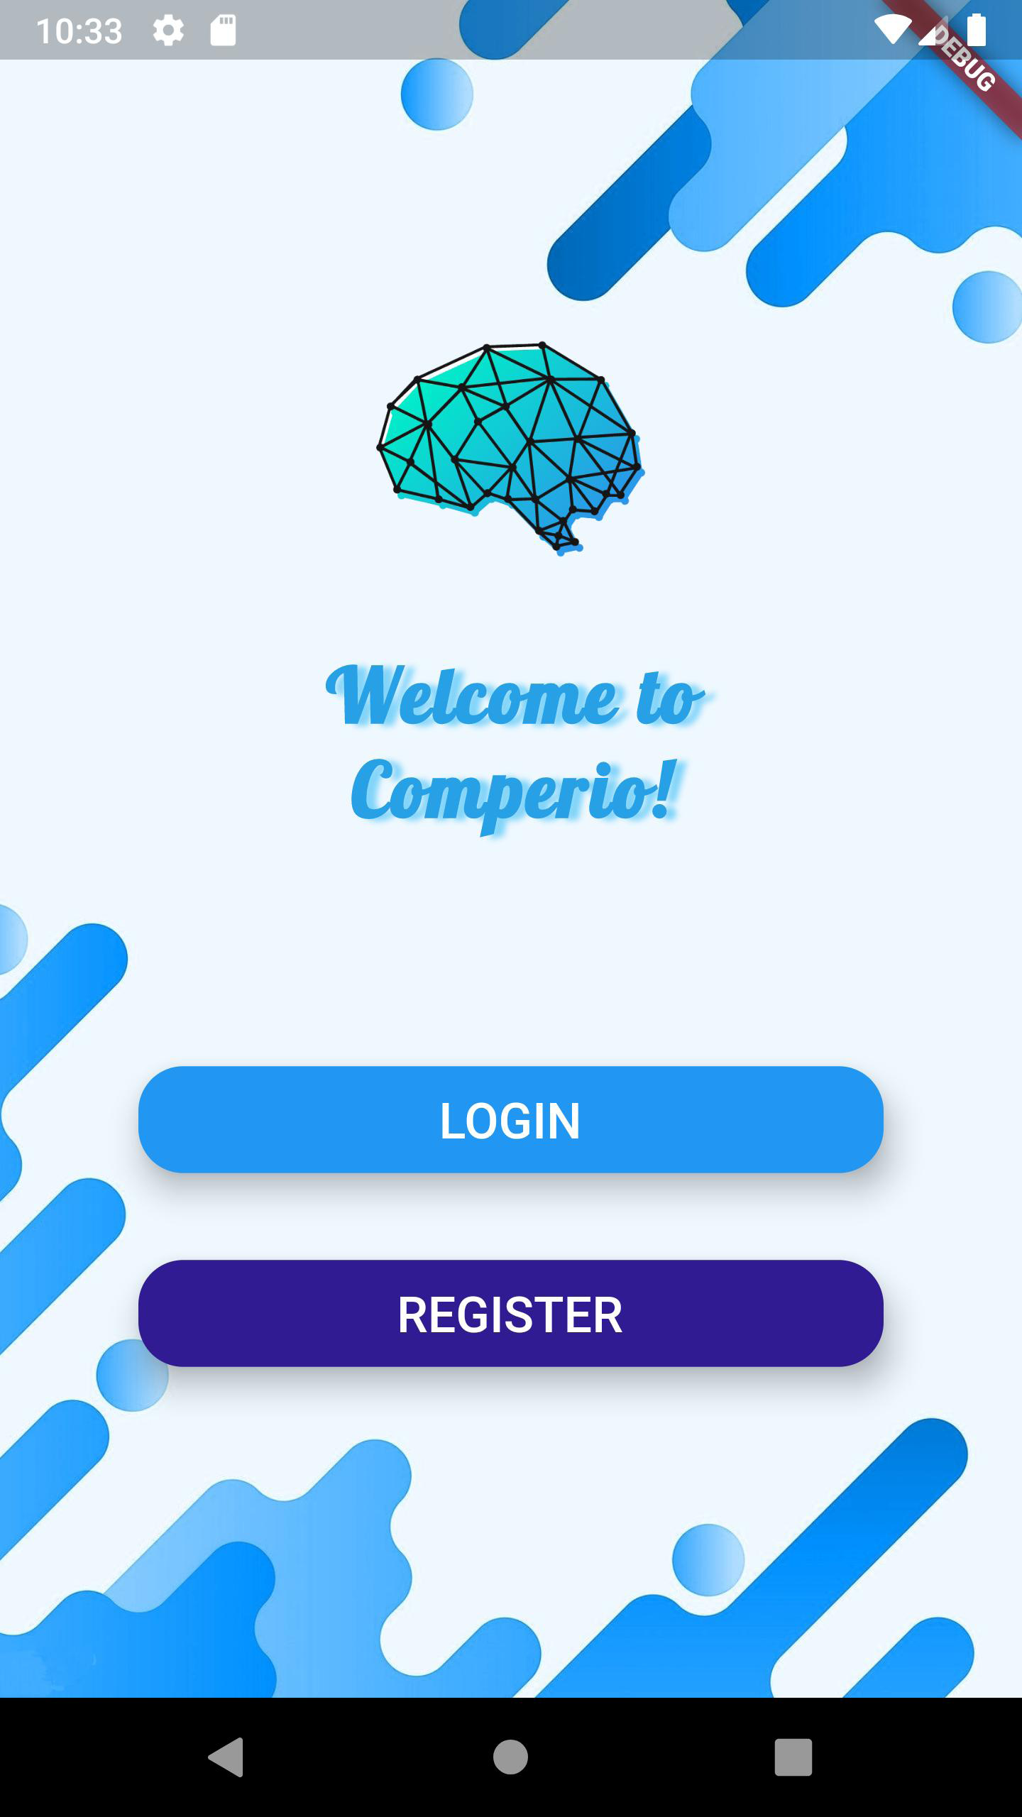

Registration Screen

1. import 'dart:io';
2. import 'package:cloud_firestore/cloud_firestore.dart' show FirebaseFirestore;
3. import 'package:comperio/constants.dart';
4. import 'package:comperio/screen/contacted_person_screen.dart';
5. import 'package:comperio/screen_app_logo.dart';
6. import 'package:firebase_auth/firebase_auth.dart';
7. import 'package:firebase_storage/firebase_storage.dart';
8. import 'package:flutter/cupertino.dart';
9. import 'package:flutter/material.dart';
10. import 'package:flutter/widgets.dart';
11. import 'package:image_picker/image_picker.dart';
12. import 'package:modal_progress_hud/modal_progress_hud.dart';
13. import 'package:path/path.dart';
14. import '../helper_functions.dart';
15. class RegistrationScreen extends StatefulWidget {
16. final String id = 'RegistrationScreen';
17. @override
18. _RegistrationScreenState createState() => _RegistrationScreenState();
19. }
20. class _RegistrationScreenState extends State<RegistrationScreen> {
21. final GlobalKey<FormState> _formKey = GlobalKey<FormState>();
22. bool _autoValidate = false;
23. bool showSpinner = false;
24. final _auth = FirebaseAuth.instance;
25. String email;
26. String username;
27. String password;
28. File _image;
29. String url = 'https://firebasestorage.googleapis.com/v0/b/comperio-1071d.appspot.com/o/default-profile.webp?alt=media&token=52b10457-a10a-417e-b5af-3d84e5833fae';
30. Future getImages() async {
31. PickedFile pickedFile = await ImagePicker().getImage(source: ImageSource.gallery);
32. var image = File(pickedFile.path);
33. setState(() {
34. _image = image;
35. });
36. }
37. void _addToDatabase(String userName, String dpUrl) {
38. print('dpurl is: $dpUrl');
39. List<String> splitList = username.split(" ");
40. List<String> indexList = [];
41. for (int i = 0; i < splitList.length; i++) {
42. for (int y = 1; y < splitList[i].length + 1; y++) {
43. indexList.add(splitList[i].substring(0, y).toLowerCase());
44. }
45. }
46. FirebaseFirestore.instance.collection('users').doc().set({
47. 'username': userName,
48. 'searchKeywords': indexList,
49. 'profileURL': dpUrl,
50. 'email': email,
51. });
52. }
53. Future uploadPic(BuildContext context) async {
54. String fileName = basename(_image.path);
55. StorageReference firebaseStorageRef =
56. FirebaseStorage.instance.ref().child(fileName);
57. StorageUploadTask uploadTask = firebaseStorageRef.putFile(_image);
58. var dowUrl = await (await uploadTask.onComplete).ref.getDownloadURL();
59. url = dowUrl.toString();
60. print(url);
61. StorageTaskSnapshot taskSnapshot = await uploadTask.onComplete;
62. setState(() {
63. print("Profile Picture uploaded")
64. });
65. }
66. String validateEmail(String value) {
67. Pattern pattern = r'^(([^<>()[\]\\.,;:\s@\"]+(\.[^<>()[\]\\.,;:\s@\"]+)*)|(\".+\"))@((\[[0-9]{1,3}\.[0-9]{1,3}\.[0-9]{1,3}\.[0-9]{1,3}\])|(([a-zA-Z\-0-9]+\.)+[a-zA-Z]{2,}))$';
68. RegExp regex = new RegExp(pattern);
69. if (!regex.hasMatch(value))
70. return 'Enter Valid Email';
71. else
72. return null;
73. }
74. String validateUserName(String value) {
75. Pattern pattern = r'^[A-Za-z0-9]+(?:[ _-][A-Za-z0-9]+)*$';
76. RegExp regex = new RegExp(pattern);
77. !regex.hasMatch(value) ? return 'Invalid username' : return null;
78. }
79. String validatePassword(String value) {
80. Pattern pattern = r'^(?=.*[0-9]+.*)(?=.*[a-zA-Z]+.*)[0-9a-zA-Z]{6,}$';
81. RegExp regex = new RegExp(pattern);
82. !regex.hasMatch(value) ? return 'Invalid Password, include letters and numbers' : return null;
83. }
84. bool _validateInputs() {
85. if (_formKey.currentState.validate())
86. _formKey.currentState.save();
87. return true;
88. } else {
89. setState(() {
90. _autoValidate = true;
91. });
92. return false;
93. }
94. }
95. @override
96. Widget build(BuildContext context) {
97. return Container(
98. decoration: BoxDecoration(
99. image: DecorationImage(
100. image: AssetImage('images/app-background.jpg'),
101. fit: BoxFit.cover,
102. ),
103. ),
104. constraints: BoxConstraints.expand(),
105. child: Scaffold(
106. resizeToAvoidBottomInset: true,
107. resizeToAvoidBottomPadding: true,
108. backgroundColor: Colors.transparent,
109. body: ModalProgressHUD(
110. inAsyncCall: showSpinner,
111. child: Container(
112. child: Column(
113. crossAxisAlignment: CrossAxisAlignment.start,
114. children: <Widget>[
115. Container(
116. padding: EdgeInsets.only(
117. top: 60.0, left: 30.0, right: 30.0, bottom: 30.0),
118. child: Column(
119. crossAxisAlignment: CrossAxisAlignment.start,
120. children: <Widget>[
121. ScreenAppLogo(),
122. Text(
123. 'Comperio',
124. style: KAppNameTextStyle,
125. ),
126. ],
127. ),
128. ),
129. Flexible(
130. fit: FlexFit.tight,
131. child: Container(
132. width: double.infinity,
133. padding: EdgeInsets.only(left: 20.0, right: 20.0),
134. decoration: BoxDecoration(
135. color: Colors.white,
136. borderRadius: BorderRadius.only(
137. topLeft: Radius.circular(20.0),
138. topRight: Radius.circular(20.0),
139. ),
140. ),
141. child: SingleChildScrollView(
142. child: Padding(
143. padding: const EdgeInsets.only(
144. left: 16.0, right: 16.0, top: 25, bottom: 16.0),
145. child: Column(
146. mainAxisSize: MainAxisSize.min,
147. crossAxisAlignment: CrossAxisAlignment.stretch,
148. children: <Widget>[
149. Row(
150. mainAxisAlignment: MainAxisAlignment.spaceBetween,
151. children: [
152. Column(
153. crossAxisAlignment: CrossAxisAlignment.start,
154. children: [
155. Text(
156. 'New',
157. style: KCardTextStyle,
158. ),
159. SizedBox(
160. height: 5.0,
161. ),
162. Text(
163. 'Account',
164. style: KCardTextStyle,
165. ),
166. ],
167. ),
168. Container(
169. child: Stack(
170. alignment: Alignment.center,
171. overflow: Overflow.visible,
172. children: [
173. Container(
174. width: 80.0,
175. height: 80.0,
176. child: CircleAvatar(
177. radius: 40.0,
178. backgroundColor: Colors.black12,
179. child: ClipOval(
180. child: SizedBox(
181. width: 80.0,
182. height: 80.0,
183. child: (_image != null)
184. ? Image.file(
185. _image,
186. fit: BoxFit.fill,
187. )
188. : Image.asset(
189. 'images/default-profile.jpg',
190. fit: BoxFit.fill,
191. ),
192. ),
193. ),
194. ),
195. ),
196. Positioned(
197. top: -1,
198. right: -30,
199. bottom: -40,
200. left: 40,
201. child: IconButton(
202. icon: Icon(
203. Icons.camera,
204. color: Colors.blueAccent,
205. size: 20,
206. ),
207. onPressed: () {
208. getImages();
209. },
210. ),
211. ),
212. ],
213. ),
214. ),
215. ],
216. ),
217. SizedBox(
218. height: 30.0,
219. ),
220. Flexible(
221. fit: FlexFit.loose,
222. child: Form(
223. key: _formKey,
224. autovalidate: _autoValidate,
225. child: Column(
226. mainAxisAlignment:
227. MainAxisAlignment.spaceEvenly,
228. children: <Widget>[
229. TextFormField(
230. keyboardType: TextInputType.emailAddress,
231. decoration: const InputDecoration(
232. icon: Icon(Icons.email),
233. hintText: 'Enter your Email',
234. hintStyle: TextStyle(
235. color: Colors.grey,
236. ),
237. labelText: 'Email *',
238. ),
239. validator: validateEmail,
240. onSaved: (String value) {
241. email = value;
242. },
243. ),
244. SizedBox(
245. height: 20.0,
246. ),
247. TextFormField(
248. decoration: const InputDecoration(
249. icon: Icon(Icons.person),
250. hintText: 'Enter Username',
251. hintStyle: TextStyle(
252. color: Colors.grey,
253. ),
254. labelText: 'Username *',
255. ),
256. validator: validateUserName,
257. onSaved: (String value) {
258. username = value;
259. },
260. ),
261. SizedBox(
262. height: 20.0,
263. ),
264. TextFormField(
265. decoration: const InputDecoration(
266. icon: Icon(Icons.lock),
267. hintText: 'Enter the password',
268. hintStyle: TextStyle(
269. color: Colors.grey,
270. ),
271. labelText: 'Password *',
272. ),
273. obscureText: true,
274. validator: validatePassword,
275. onSaved: (String value) {
276. password = value;
277. },
278. ),
279. SizedBox(
280. height: 50.0,
281. ),
282. Padding(
283. padding: const EdgeInsets.symmetric(
284. horizontal: 30.0,
285. ),
286. child: RaisedButton(
287. elevation: 10.0,
288. shape: StadiumBorder(),
289. color: Colors.lightBlueAccent,
290. onPressed: () async {
291. bool isShowSpinner =
292. _validateInputs();
293. setState(() {
294. showSpinner = isShowSpinner;
295. });
296. try {
297. await _auth
298. .createUserWithEmailAndPassword(
299. email: email,
300. password: password)
301. .then((newUser) {
302. if (newUser != null) {
303. HelperFunctions
304. .saveUserLoggedInSharedPreference(
305. true);
306. HelperFunctions
307. .saveUserNameSharedPreference(
308. username);
309. HelperFunctions
310. .saveUserEmailSharedPreference(
311. email);
312. HelperFunctions
313. .saveUserPhotoUrlSharedPreference(url);
314. Navigator.pushNamed(context,
315. ContactedPersonScreen().id);
316. }
317. });
318. if (_image != null) {
319. await uploadPic(context);
320. }
321. _addToDatabase(username, url);
322. setState(() {
323. showSpinner = false;
324. });
325. } catch (e) {
326. print(e);
327. }
328. },
329. child: Text(
330. 'Sign up',
331. style: KLoginRegistrationButtonStyle,
332. ),
333. padding: EdgeInsets.symmetric(
334. vertical: 15.0,
335. horizontal: 60.0,
336. ),
337. ),
338. ),
339. ],
340. ),
341. ),
342. ),
343. ],
344. ),
345. ),
346. ),
347. ),
348. ),
349. ],
350. ),
351. ),
352. ),
353. ),
354. );
355. }
356. }

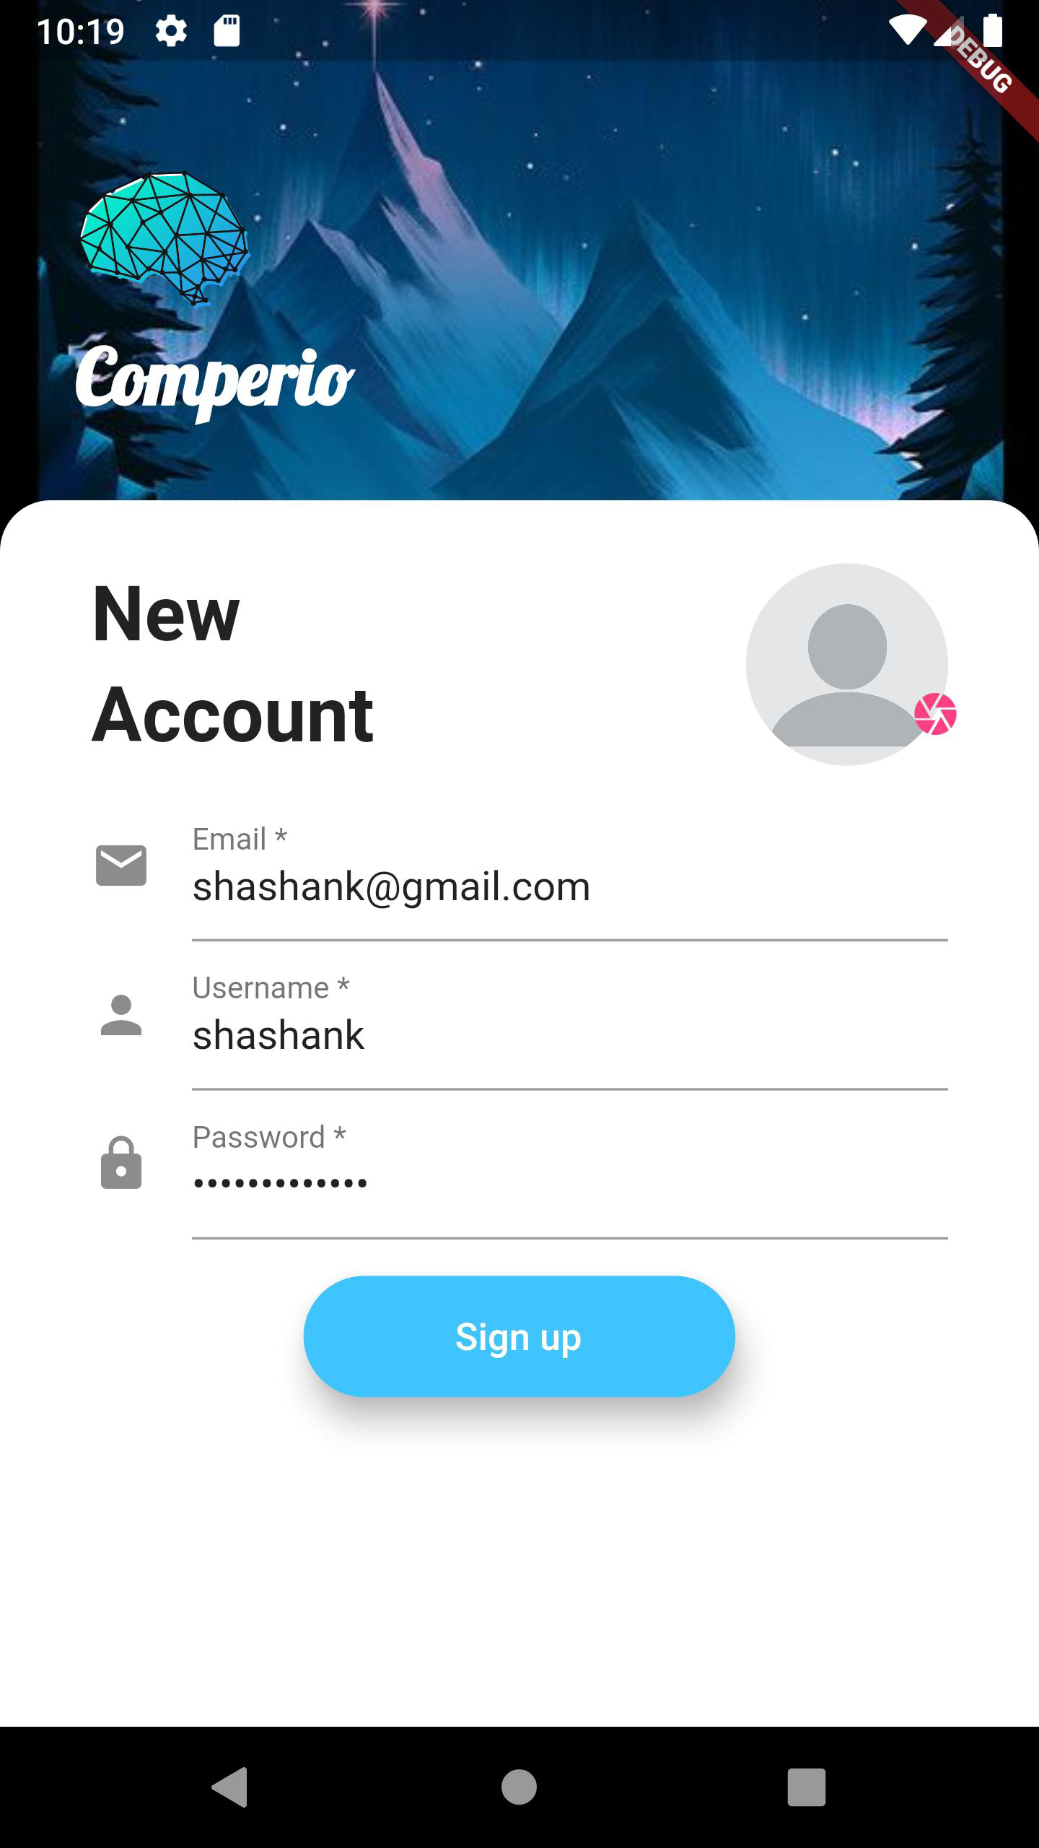

Login Screen

1. import 'package:cloud_firestore/cloud_firestore.dart' show FirebaseFirestore;
2. import 'package:comperio/constants.dart';
3. import 'package:comperio/screen/contacted_person_screen.dart';
4. import 'package:comperio/screen_app_logo.dart';
5. import 'package:firebase_auth/firebase_auth.dart';
6. import 'package:flutter/cupertino.dart';
7. import 'package:flutter/material.dart';
8. import 'package:modal_progress_hud/modal_progress_hud.dart';
9. import '../helper_functions.dart';
10. class LoginScreen extends StatefulWidget {
11. final String id = 'LoginScreen';
12. @override
13. _LoginScreenState createState() => _LoginScreenState();
14. }
15. class _LoginScreenState extends State<LoginScreen> {
16. final GlobalKey<FormState> _formKey = GlobalKey<FormState>();
17. bool _autoValidate = false;
18. bool showSpinner = false;
19. final _auth = FirebaseAuth.instance;
20. String email;
21. String password;
22. String validateEmail(String value) {
23. Pattern pattern =
24. r'^(([^<>()[\]\\.,;:\s@\"]+(\.[^<>()[\]\\.,;:\s@\"]+)*)|(\".+\"))@((\[[0-9]{1,3}\.[0-9]{1,3}\.[0-9]{1,3}\.[0-9]{1,3}\])|(([a-zA-Z\-0-9]+\.)+[a-zA-Z]{2,}))$';
25. RegExp regex = new RegExp(pattern);
26. return !regex.hasMatch(value) ? 'Enter Valid Email' : null;
27. }
28. String validatePassword(String value) {
29. Pattern pattern = r'^(?=.*[0-9]+.*)(?=.*[a-zA-Z]+.*)[0-9a-zA-Z]{6,}$';
30. RegExp regex = new RegExp(pattern);
31. if (!regex.hasMatch(value))
32. return 'Invalid password';
33. else
34. return null;
35. }
36. bool _validateInputs() {
37. if (_formKey.currentState.validate()) {
38. _formKey.currentState.save();
39. return true;
40. } else {
41. setState(() {
42. _autoValidate = true;
43. });
44. return false;
45. }
46. }
47. @override
48. Widget build(BuildContext context) {
49. return Container(
50. decoration: BoxDecoration(
51. color: Colors.lightBlueAccent,
52. image: DecorationImage(
53. image: AssetImage('images/app-background-2.jpg'),
54. fit: BoxFit.cover,
55. ),
56. ),
57. constraints: BoxConstraints.expand(),
58. child: Scaffold(
59. resizeToAvoidBottomInset: true,
60. resizeToAvoidBottomPadding: true,
61. backgroundColor: Colors.transparent,
62. body: ModalProgressHUD(
63. inAsyncCall: showSpinner,
64. child: Container(
65. child: Column(
66. crossAxisAlignment: CrossAxisAlignment.start,
67. children: <Widget>[
68. Container(
69. padding: EdgeInsets.only(
70. top: 60.0, left: 30.0, right: 30.0, bottom: 30.0),
71. child: Column(
72. crossAxisAlignment: CrossAxisAlignment.start,
73. children: <Widget>[
74. ScreenAppLogo(),
75. Text(
76. 'Comperio',
77. style: KAppNameTextStyle,
78. ),
79. ],
80. ),
81. ),
82. Flexible(
83. fit: FlexFit.tight,
84. child: Container(
85. width: double.infinity,
86. padding: EdgeInsets.symmetric(horizontal: 20.0),
87. decoration: BoxDecoration(
88. color: Colors.white,
89. borderRadius: BorderRadius.only(
90. topLeft: Radius.circular(20.0),
91. topRight: Radius.circular(20.0),
92. ),
93. ),
94. child: Padding(
95. padding: const EdgeInsets.only(
96. left: 16.0, right: 16.0, top: 35, bottom: 16.0),
97. child: Form(
98. key: _formKey,
99. autovalidate: _autoValidate,
100. child: SingleChildScrollView(
101. child: Column(
102. mainAxisSize: MainAxisSize.min,
103. crossAxisAlignment: CrossAxisAlignment.stretch,
104. children: <Widget>[
105. Text(
106. 'Welcome',
107. style: KCardTextStyle,
108. ),
109. SizedBox(
110. height: 5.0,
111. ),
112. Text(
113. 'Back',
114. style: KCardTextStyle,
115. ),
116. SizedBox(
117. height: 30.0,
118. ),
119. Flexible(
120. fit: FlexFit.loose,
121. child: Column(
122. mainAxisAlignment:
123. MainAxisAlignment.spaceEvenly,
124. children: <Widget>[
125. TextFormField(
126. keyboardType: TextInputType.emailAddress,
127. decoration: const InputDecoration(
128. icon: Icon(Icons.person),
129. hintText: 'Enter the Email',
130. hintStyle: TextStyle(
131. color: Colors.grey,
132. ),
133. labelText: 'Email *',
134. ),
135. validator: validateEmail,
136. onSaved: (String value) {
137. email = value;
138. },
139. ),
140. SizedBox(
141. height: 30.0,
142. ),
143. TextFormField(
144. decoration: const InputDecoration(
145. icon: Icon(Icons.lock),
146. hintText: 'Enter the password',
147. hintStyle: TextStyle(
148. color: Colors.grey,
149. ),
150. labelText: 'Password *',
151. ),
152. obscureText: true,
153. validator: validatePassword,
154. onSaved: (String value) {
155. password = value;
156. },
157. ),
158. SizedBox(
159. height: 50.0,
160. ),
161. Padding(
162. padding: const EdgeInsets.symmetric(
163. horizontal: 30.0,
164. ),
165. child: RaisedButton(
166. elevation: 10.0,
167. shape: StadiumBorder(),
168. color: Colors.lightBlueAccent,
169. onPressed: () async {
170. bool isShowSpinner =
171. _validateInputs();
172. setState(() {
173. showSpinner = isShowSpinner;
174. });
175. try {
176. await _auth
177. .signInWithEmailAndPassword(
178. email: email,
179. password: password)
180. .then((newUser) async {
181. if (newUser != null) {
182. var userInfoSnapshot =
183. await FirebaseFirestore
184. .instance
185. .collection("users")
186. .where('email',
187. isEqualTo: email)
188. .getDocuments()
189. .catchError((e) {
190. print(e.toString());
191. });
192. HelperFunctions
193. .saveUserLoggedInSharedPreference(
194. true);
195. HelperFunctions
196. .saveUserNameSharedPreference(
197. userInfoSnapshot
198. .documents[0]
199. .get('username'));
200. HelperFunctions
201. .saveUserEmailSharedPreference(userInfoSnapshot.documents[0].get('email'));
202. HelperFunctions
203. .saveUserPhotoUrlSharedPreference(userInfoSnapshot.documents[0].get('profileURL'));
204. Navigator.pushNamed(context,
205. ContactedPersonScreen().id);
206. }
207. });
208. setState(() {
209. showSpinner = false;
210. });
211. } catch (e) {
212. print(e);
213. }
214. },
215. child: Text(
216. 'Log in',
217. style: KLoginRegistrationButtonStyle,
218. ),
219. padding: EdgeInsets.symmetric(
220. vertical: 15.0,
221. horizontal: 60.0,
222. ),
223. ),
224. ),
225. ],
226. ),
227. ),
228. ],
229. ),
230. ),
231. ),
232. ),
233. ),
234. ),
235. ],
236. ),
237. ),
238. ),
239. ),
240. );
241. }
242. }

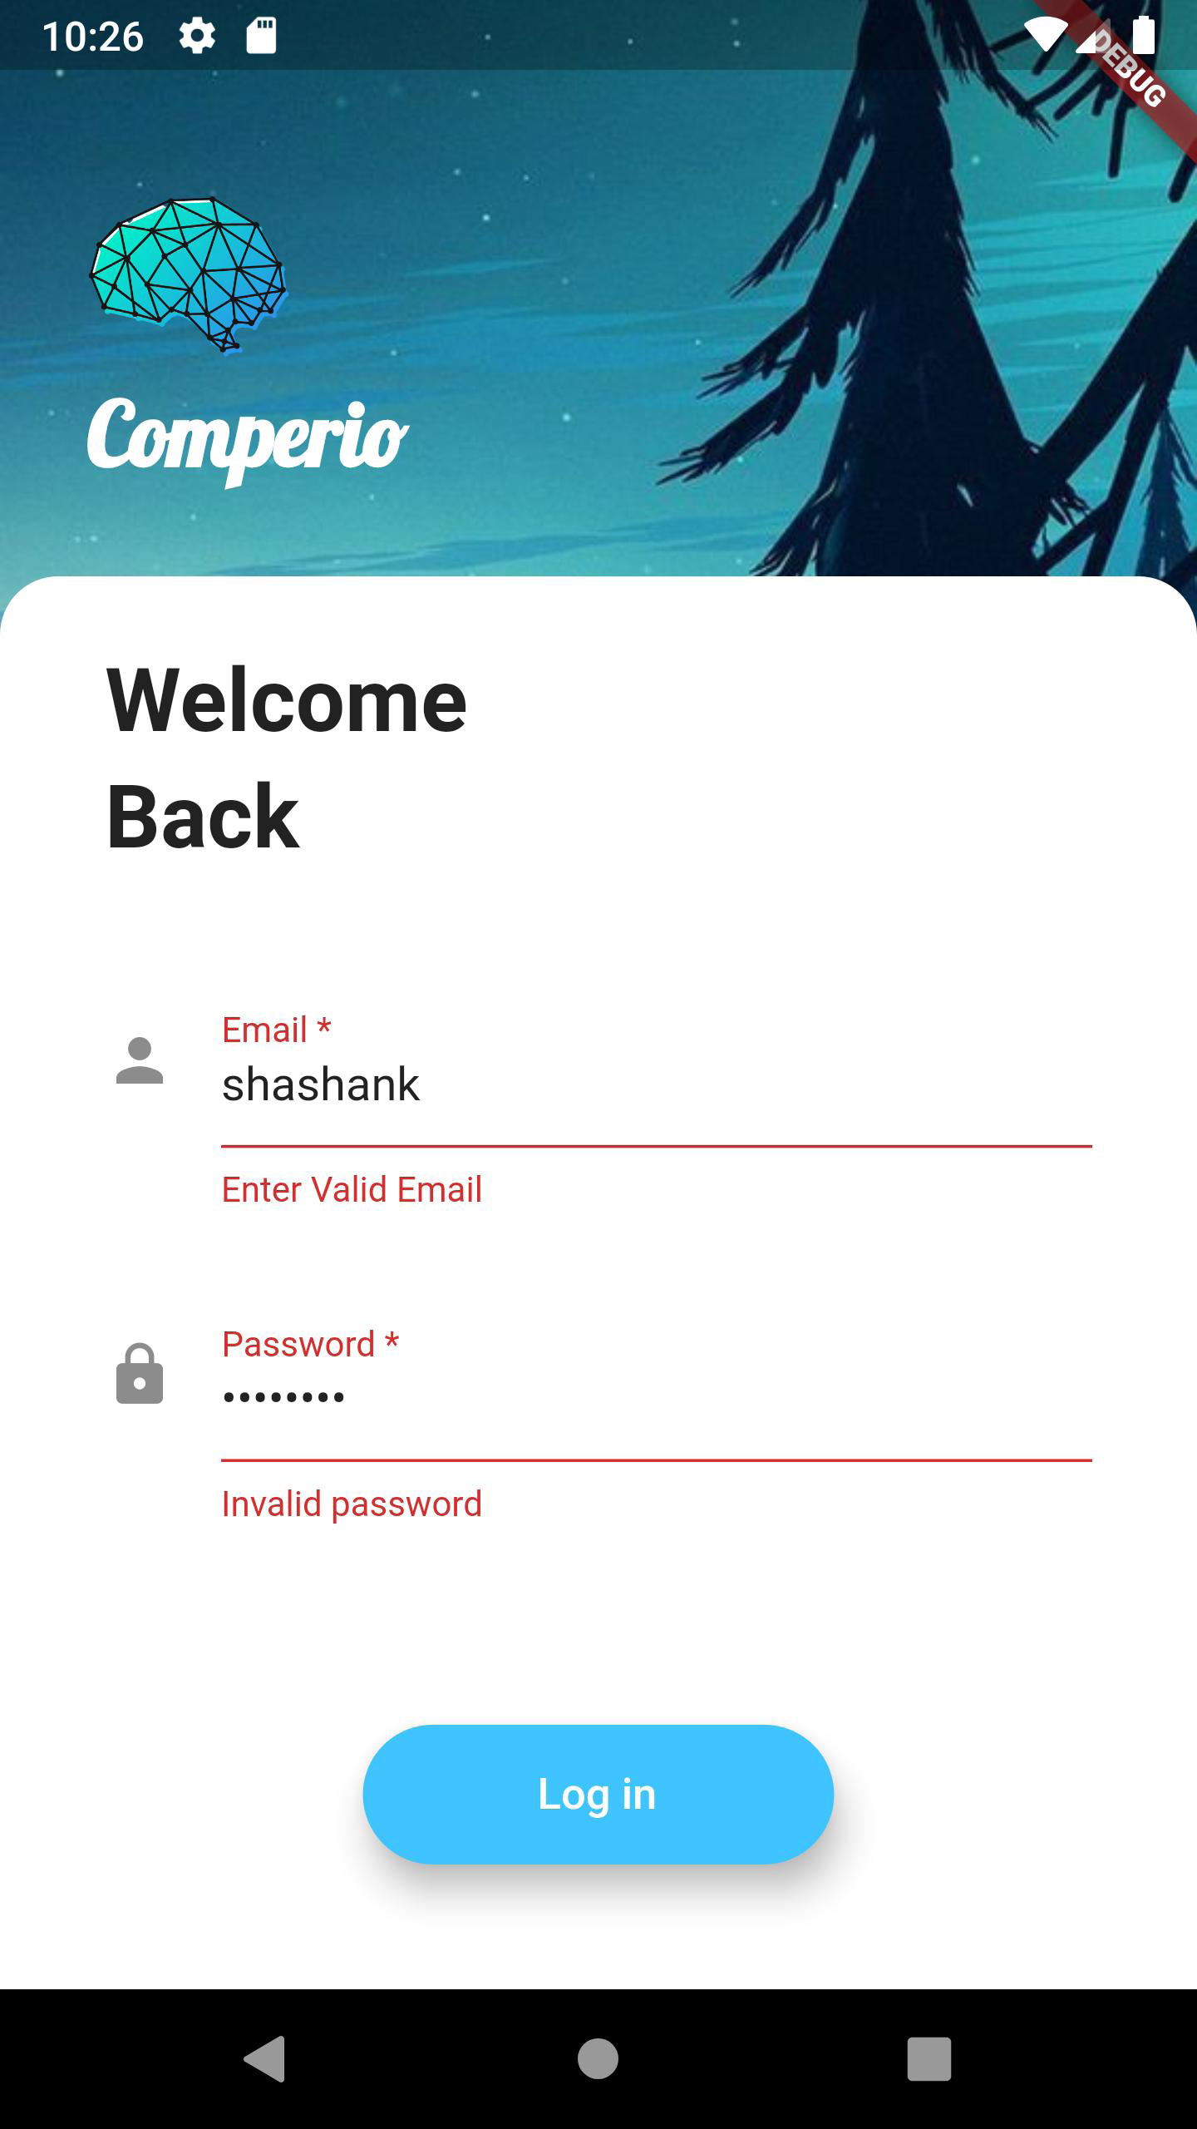

Chat Screen

1. import 'package:cloud_firestore/cloud_firestore.dart';
2. import 'package:comperio/app_icons.dart';
3. import 'package:comperio/attach_file_components.dart';
4. import 'package:comperio/constants.dart';
5. import 'package:comperio/screen/contacted_person_screen.dart';
6. import 'package:firebase_auth/firebase_auth.dart';
7. import 'package:flutter/cupertino.dart';
8. import 'package:flutter/material.dart';
9. import 'package:font_awesome_flutter/font_awesome_flutter.dart';
10. import 'package:intl/intl.dart';
11. final _firestore = FirebaseFirestore.instance;
12. User loggedInUser;
13. class ChatScreen extends StatefulWidget {
14. final String id = 'ChatScreen';
15. @override
16. _ChatScreenState createState() => _ChatScreenState();
17. }
18. class _ChatScreenState extends State<ChatScreen> {
19. final messageTextController = TextEditingController();
20. final _auth = FirebaseAuth.instance;
21. String messageText;
22. @override
23. void initState() {
24. super.initState();
25. getCurrentUser();
26. }
27. void getCurrentUser() async {
28. try {
29. final user = await _auth.currentUser;
30. if (user != null) {
31. loggedInUser = user;
32. print(loggedInUser.email);
33. }
34. } catch (e) {
35. print(e);
36. }
37. }
38. void messageStream() async {
39. await for (var snapshot in _firestore.collection('Messages').snapshots()) {
40. for (var message in snapshot.docs) {
41. print(message.data());
42. }
43. }
44. }
45. @override
46. Widget build(BuildContext context) {
47. return Container(
48. decoration: BoxDecoration(
49. color: Color(0xFF1d2d50),
50. ),
51. constraints: BoxConstraints.expand(),
52. child: Scaffold(
53. resizeToAvoidBottomInset: false,
54. resizeToAvoidBottomPadding: false,
55. backgroundColor: Colors.transparent,
56. body: Column(
57. crossAxisAlignment: CrossAxisAlignment.start,
58. children: <Widget>[
59. Container(
60. padding: EdgeInsets.only(
61. top: 40.0, left: 10.0, right: 20.0, bottom: 20.0),
62. child: Row(
63. mainAxisAlignment: MainAxisAlignment.start,
64. children: [
65. IconButton(
66. icon: AppIcons(
67. iconName: Icons.arrow_back,
68. iconSize: 30.0,
69. colour: Colors.white,
70. ),
71. onPressed: () {
72. Navigator.pushNamed(context, ContactedPersonScreen().id);
73. },
74. ),
75. CircleAvatar(
76. radius: 17.0,
77. backgroundColor: Colors.white,
78. ),
79. SizedBox(
80. width: 10.0,
81. ),
82. Text(
83. 'username',
84. style: KUserTextStyle,
85. ),
86. ],
87. ),
88. ),
89. Expanded(
90. child: Container(
91. decoration: BoxDecoration(
92. color: Colors.white,
93. image: DecorationImage(
94. image: AssetImage('images/chat_bg8.jpeg'),
95. fit: BoxFit.cover,
96. ),
97. borderRadius: BorderRadius.only(
98. topLeft: Radius.circular(20.0),
99. topRight: Radius.circular(20.0),
100. ),
101. ),
102. child: Column(
103. mainAxisAlignment: MainAxisAlignment.spaceBetween,
104. crossAxisAlignment: CrossAxisAlignment.stretch,
105. children: <Widget>[
106. MessagesStream(),
107. ],
108. ),
109. ),
110. ),
111. Container(
112. padding: EdgeInsets.all(10.0),
113. color: Colors.white,
114. child: SingleChildScrollView(
115. child: Container(
116. margin: EdgeInsets.only(bottom: 5.0, left: 3.0),
117. padding: EdgeInsets.only(
118. bottom: MediaQuery.of(context).viewInsets.bottom),
119. child: Row(
120. crossAxisAlignment: CrossAxisAlignment.center,
121. children: <Widget>[
122. IconButton(
123. icon: Icon(FontAwesomeIcons.paperclip),
124. color: Colors.blueGrey,
125. onPressed: () {
126. showModalBottomSheet(
127. context: context,
128. builder: (context) {
129. return AttachFileBottomSheet();
130. },
131. );
132. },
133. ),
134. Expanded(
135. child: TextField(
136. keyboardType: TextInputType.multiline,
137. maxLines: null,
138. controller: messageTextController,
139. onChanged: (value) {
140. //do something when pressed
141. messageText = value;
142. },
143. decoration: InputDecoration(
144. contentPadding: EdgeInsets.symmetric(
145. vertical: 10.0, horizontal: 20.0),
146. hintText: 'Type your message here...',
147. enabledBorder: OutlineInputBorder(
148. borderRadius:
149. BorderRadius.all(Radius.circular(12.0)),
150. borderSide: BorderSide(
151. color: Colors.grey,
152. ),
153. ),
154. focusedBorder: OutlineInputBorder(
155. borderRadius:
156. BorderRadius.all(Radius.circular(10.0)),
157. borderSide:
158. BorderSide(color: Colors.lightBlueAccent),
159. ),
160. ),
161. ),
162. ),
163. RaisedButton(
164. padding: EdgeInsets.all(15.0),
165. color: Color(0xFF1d2d50),
166. onPressed: () {
167. messageTextController.clear();
168. _firestore.collection('Messages').add({
169. 'message': messageText,
170. 'sender': loggedInUser.email,
171. 'Date': DateFormat('dd-MMM-yy hh:mm')
172. .format(DateTime.now())
173. .toString(),
174. 'fileUrl': " ",
175. 'orderDateFormat': DateFormat('dd-MMM-yy hh:mm:ss')
176. .format(DateTime.now())
177. .toString(),
178. });
179. },
180. shape: CircleBorder(),
181. child: AppIcons(
182. iconName: Icons.send,
183. iconSize: 20.0,
184. colour: Colors.white,
185. ),
186. ),
187. ],
188. ),
189. ),
190. ),
191. )
192. ],
193. ),
194. ),
195. );
196. }
197. }
198. class MessagesStream extends StatelessWidget {
199. @override
200. Widget build(BuildContext context) {
201. return StreamBuilder<QuerySnapshot>(
202. stream: _firestore
203. .collection('Messages')
204. .orderBy('orderDateFormat')
205. .snapshots(),
206. builder: (context, snapshot) {
207. if (!snapshot.hasData) {
208. return Center(
209. child: CircularProgressIndicator(
210. backgroundColor: Colors.lightBlueAccent,
211. ),
212. );
213. }
214. final messages = snapshot.data.docs.reversed;
215. List<MessageBubble> messageBubbles = [];
216. for (var message in messages) {
217. final messageText = message.data()['message'];
218. final messageSender = message.data()['sender'];
219. final messageDateTime = message.data()['Date'];
220. final messageFile = message.data()['fileUrl'];
221. final currentUser = loggedInUser.email;
222. final messageBubble = MessageBubble(
223. sender: messageSender,
224. text: messageText,
225. dateTime: messageDateTime,
226. isMe: currentUser == messageSender,
227. messageFileUrl: messageFile,
228. );
229. messageBubbles.add(messageBubble);
230. }
231. return Expanded(
232. child: ListView(
233. reverse: true,
234. padding: EdgeInsets.symmetric(
235. horizontal: 10.0,
236. vertical: 20.0,
237. ),
238. children: messageBubbles,
239. ),
240. );
241. },
242. );
243. }
244. }
245. class MessageBubble extends StatelessWidget {
246. final String sender;
247. final String text;
248. final bool isMe;
249. final String dateTime;
250. final String messageFileUrl;
251. MessageBubble(
252. {this.sender, this.text, this.isMe, this.dateTime, this.messageFileUrl});
253. @override
254. Widget build(BuildContext context) {
255. return Padding(
256. padding: EdgeInsets.all(10.0),
257. child: Column(
258. crossAxisAlignment:
259. isMe ? CrossAxisAlignment.end : CrossAxisAlignment.start,
260. children: <Widget>[
261. Text(
262. sender,
263. style: TextStyle(
264. fontSize: 12.0,
265. color: Colors.black54,
266. ),
267. ),
268. (text != " ")
269. ? Container(
270. constraints: BoxConstraints(
271. maxWidth: 2 * (MediaQuery.of(context).size.width) / 3,
272. ),
273. child: Material(
274. borderRadius: isMe
275. ? BorderRadius.only(
276. topLeft: Radius.circular(30.0),
277. bottomLeft: Radius.circular(30.0),
278. bottomRight: Radius.circular(30.0),
279. )
280. : BorderRadius.only(
281. topRight: Radius.circular(30.0),
282. bottomLeft: Radius.circular(30.0),
283. bottomRight: Radius.circular(30.0),
284. ),
285. elevation: 10.0,
286. color: isMe ? Color(0xff81d4fa) : Colors.white,
287. child: Padding(
288. padding: EdgeInsets.symmetric(
289. vertical: 12.0, horizontal: 20.0),
290. child: Text(
291. text,
292. style: TextStyle(
293. fontSize: 15.0,
294. color: Colors.black,
295. ),
296. ),
297. ),
298. ),
299. )
300. : ClipRRect(
301. borderRadius: BorderRadius.circular(8.0),
302. child: Column(
303. mainAxisAlignment: MainAxisAlignment.spaceEvenly,
304. children: <Widget>[
305. Stack(
306. alignment: AlignmentDirectional.center,
307. children: <Widget>[
308. Container(
309. width: 130,
310. color: Colors.black87,
311. height: 80,
312. child: Column(
313. mainAxisAlignment: MainAxisAlignment.spaceEvenly,
314. children: <Widget>[
315. Icon(
316. Icons.insert_drive_file,
317. color: Colors.lightBlueAccent,
318. ),
319. Text(
320. 'File',
321. style: TextStyle(
322. fontSize: 20,
323. color: isMe
324. ? Colors.lightBlueAccent
325. : Colors.lightBlueAccent),
326. ),
327. ],
328. ),
329. ),
330. ],
331. ),
332. Container(
333. height: 40,
334. width: 130.0,
335. color: Colors.lightBlueAccent,
336. child: IconButton(
337. icon: Icon(
338. Icons.file_download,
339. color: Colors.white,
340. ),
341. onPressed: () {},
342. ),
343. )
344. ],
345. ),
346. ),
347. Text(
348. dateTime,
349. style: TextStyle(
350. fontSize: 10.0,
351. color: Colors.black54,
352. ),
353. ),
354. ],
355. ),
356. );
357. }
358. }

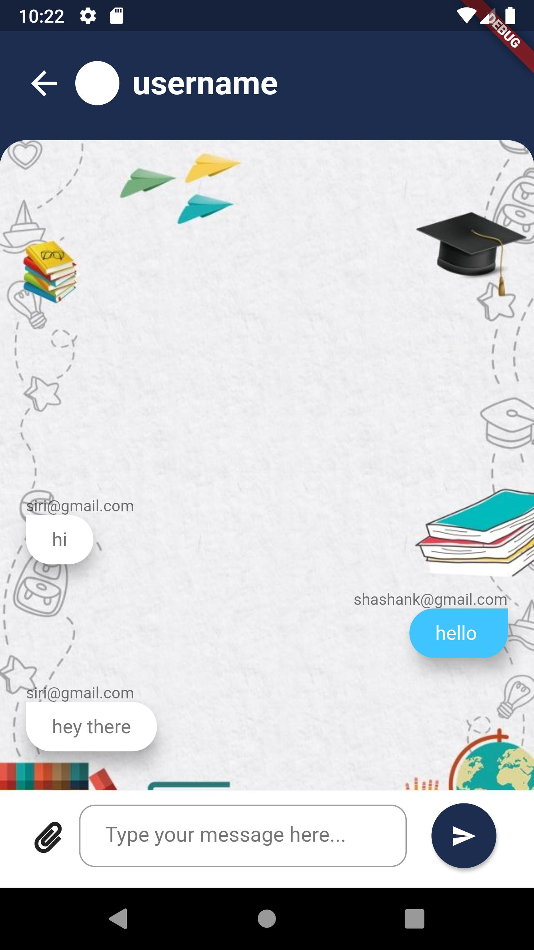

Profile Screen

1. import 'package:cloud_firestore/cloud_firestore.dart';
2. import 'package:comperio/helper_functions.dart';
3. import 'package:flutter/material.dart';
4. class ProfileScreen extends StatefulWidget {
5. final String id = 'ProfileScreen';
6. @override
7. _ProfileScreenState createState() => _ProfileScreenState();
8. }
9. class _ProfileScreenState extends State<ProfileScreen> {
10. QuerySnapshot snapshotUserInfo;
11. String userName;
12. String emailId;
13. String picURL;
14. getUserInfo() async {
15. userName = await HelperFunctions.getUserNameSharedPreference();
16. emailId = await HelperFunctions.getUserEmailSharedPreference();
17. picURL = await HelperFunctions.getUserPhotoUrlSharedPreference();
18. }
19. @override
20. void initState() {
21. super.initState();
22. getUserInfo();
23. }
24. @override
25. Widget build(BuildContext context) {
26. return MaterialApp(
27. home: Scaffold(
28. backgroundColor: Colors.teal,
29. body: SafeArea(
30. child: Container(
31. constraints: BoxConstraints.expand(),
32. decoration: BoxDecoration(
33. image: DecorationImage(
34. image: AssetImage('images/app-background-3.jpg'),
35. fit: BoxFit.cover)),
36. child: Column(
37. crossAxisAlignment: CrossAxisAlignment.center,
38. mainAxisAlignment: MainAxisAlignment.center,
39. children: <Widget>[
40. Container(
41. decoration: BoxDecoration(
42. color: Colors.white,
43. shape: BoxShape.circle,
44. boxShadow: [
45. BoxShadow(
46. blurRadius: 7.0,
47. color: Colors.black,
48. )
49. ],
50. ),
51. child: CircleAvatar(
52. radius: 50.0, backgroundImage: NetworkImage(picURL)),
53. ),
54. SizedBox(
55. height: 15.0,
56. ),
57. Text(
58. userName != null ? userName : 'abc',
59. style: TextStyle(
60. fontSize: 40.0,
61. color: Colors.white,
62. fontWeight: FontWeight.bold,
63. ),
64. ),
65. Text(
66. '@Professor',
67. style: TextStyle(
68. color: Colors.teal[100],
69. fontSize: 20.0,
70. letterSpacing: 2.5,
71. fontWeight: FontWeight.bold,
72. ),
73. ),
74. SizedBox(
75. height: 10.0,
76. ),
77. Card(
78. color: Colors.white,
79. margin: EdgeInsets.symmetric(vertical: 20.0, horizontal: 30.0),
80. child: ListTile(
81. visualDensity: VisualDensity(horizontal: 0, vertical: -4),
82. leading: Icon(Icons.email, color: Colors.teal),
83. title: Align(
84. child: Text(
85. emailId != null ? emailId : 'abc@gmail.com',
86. style: TextStyle(
87. color: Colors.teal[900],
88. fontSize: 20.0,
89. ),
90. ),
91. alignment: Alignment(-2.5, 0),
92. ),
93. ),
94. ),
95. Container(
96. height: 50.0,
97. width: 170.0,
98. child: Material(
99. borderRadius: BorderRadius.circular(20.0),
100. shadowColor: Colors.blueAccent,
101. color: Colors.blueAccent,
102. elevation: 7.0,
103. child: GestureDetector(
104. onTap: () {},
105. child: Center(
106. child: Text(
107. 'Send Message',
108. style: TextStyle(
109. color: Colors.white,
110. fontSize: 18.0,
111. fontWeight: FontWeight.bold,
112. ),
113. ),
114. ),
115. ),
116. ))
117. ],
118. ),
119. ),
120. ),
121. ),
122. );
123. }
124. }

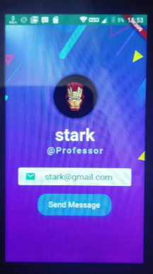

Search Screen

1. import 'package:cloud_firestore/cloud_firestore.dart';
2. import 'package:comperio/app_icons.dart';
3. import 'package:comperio/search_stream_builder.dart';
4. import 'package:flutter/material.dart';
5. import 'package:font_awesome_flutter/font_awesome_flutter.dart';
6. import '../constants.dart';
7. class SearchScreen extends StatefulWidget {
8. final String id = 'SearchScreen';
9. @override
10. _SearchScreenState createState() => _SearchScreenState();
11. }
12. class _SearchScreenState extends State<SearchScreen> {
13. final searchText = TextEditingController();
14. String name = "";
15. @override
16. Widget build(BuildContext context) {
17. return SafeArea(
18. child: Scaffold(
19. body: Container(
20. child: Column(
21. children: [
22. Row(
23. children: [
24. IconButton(
25. icon: AppIcons(
26. iconName: Icons.arrow_back,
27. iconSize: 30.0,
28. colour: Colors.indigo,
29. ),
30. onPressed: () {
31. Navigator.pop(context);
32. },
33. ),
34. Expanded(
35. child: TextField(
36. controller: searchText,
37. cursorColor: Colors.indigo,
38. autofocus: true,
39. textInputAction: TextInputAction.search,
40. style: TextStyle(
41. height: 1.5,
42. fontSize: 20.0,
43. ),
44. decoration: InputDecoration(
45. prefixIcon: Icon(FontAwesomeIcons.search, color: Colors.indigo),
46. suffixIcon: name.length > 0
47. ? IconButton(
48. icon: Icon(
49. FontAwesomeIcons.times,
50. color: Colors.blueGrey,
51. ),
52. onPressed: () {
53. setState(() {
54. searchText.clear();
55. name = "";
56. });
57. },
58. ) : null,
59. hintText: 'Search...',
60. hintStyle:TextStyle(color:Colors.grey,fontSize: 20.0,),
61. border: InputBorder.none,
62. ),
63. onChanged: (value) {
64. setState(() {
65. name = value;
66. });
67. },
68. ),
69. ),
70. ],
71. ),
72. Expanded(
73. child: SearchStreamBuilder( username: name, ),
74. ),
75. ],
76. ),
77. ),
78. ),
79. );
80. }
81. }

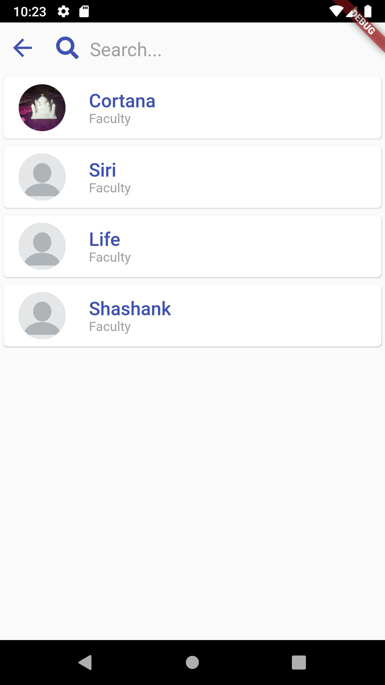

Contacted Person Screen

1. import 'package:comperio/app_icons.dart';
2. import 'package:comperio/choice.dart';
3. import 'package:comperio/constants.dart';
4. import 'package:comperio/contact_popup_menu.dart';
5. import 'package:comperio/helper_functions.dart';
6. import 'package:comperio/screen/searchScreen.dart';
7. import 'package:firebase_auth/firebase_auth.dart';
8. import 'package:flutter/material.dart';
9. import 'package:font_awesome_flutter/font_awesome_flutter.dart';
10. class ContactedPersonScreen extends StatefulWidget {
11. final String id = 'ContactedPersonScreen';
12. @override
13. _ContactedPersonScreenState createState() => _ContactedPersonScreenState();
14. }
15. List<Choice> choices = const <Choice>[
16. const Choice(title: 'Profile', icon: FontAwesomeIcons.user),
17. const Choice(title: 'Change Password', icon: FontAwesomeIcons.key),
18. const Choice(title: 'Log out', icon: FontAwesomeIcons.signOutAlt),
19. ];
20. class _ContactedPersonScreenState extends State<ContactedPersonScreen> {
21. final user = FirebaseAuth.instance.currentUser;
22. @override
23. void initState() {
24. getUserInfo();
25. super.initState();
26. }
27. getUserInfo() async => Constants.myName = await HelperFunctions.getUserNameSharedPreference();
28. @override
29. Widget build(BuildContext context) {
30. return Container(
31. decoration: BoxDecoration(
32. color: Color(0xff311b92),
33. image: DecorationImage(
34. image: AssetImage('images/app-background.jpg'),
35. fit: BoxFit.cover,
36. ),
37. ),
38. constraints: BoxConstraints.expand(),
39. child: Scaffold(
40. floatingActionButton: FloatingActionButton(
41. onPressed: () {
42. },
43. child: AppIcons(
44. iconName: Icons.group_add,
45. iconSize: 30.0,
46. colour: Colors.white,
47. ),
48. backgroundColor: Color(0xff0d47a1),
49. ),
50. resizeToAvoidBottomInset: false,
51. resizeToAvoidBottomPadding: false,
52. backgroundColor: Colors.transparent,
53. body: Column(
54. crossAxisAlignment: CrossAxisAlignment.start,
55. children: <Widget>[
56. Container(
57. padding: EdgeInsets.only(
58. top: 40.0, left: 20.0, right: 20.0, bottom: 20.0),
59. child: Row(
60. mainAxisAlignment: MainAxisAlignment.spaceBetween,
61. children: [
62. Text(
63. 'Comperio',
64. style: KAppNameTextStyle,
65. ),
66. Row(
67. mainAxisAlignment: MainAxisAlignment.end,
68. children: [
69. IconButton(
70. icon: AppIcons(
71. iconName: Icons.search,
72. colour: Colors.white,
73. iconSize: 35.0),
74. onPressed: () {
75. Navigator.pushNamed(context, SearchScreen().id);
76. },
77. ),
78. ContactPopupMenu(choices: choices),
79. ],
80. ),
81. ],
82. ),
83. ),
84. Expanded(
85. child: Container(
86. padding: EdgeInsets.symmetric(horizontal: 20.0),
87. decoration: BoxDecoration(
88. color: Colors.white,
89. borderRadius: BorderRadius.only(
90. topLeft: Radius.circular(20.0),
91. topRight: Radius.circular(20.0),
92. ),
93. ),
94. child: ListView(
95. ),
96. ),
97. ),
98. ],
99. ),
100. ),
101. );
102. }
103. }

Feedback screen

1. import 'package:comperio/app_icons.dart';
2. import 'package:comperio/constants.dart';
3. import 'package:flutter/cupertino.dart';
4. import 'package:flutter/material.dart';
5. import 'package:font_awesome_flutter/font_awesome_flutter.dart';
6. class FeedbackScreen extends StatefulWidget {
7. final String id = 'FeedbackScreen';
8. @override
9. _FeedbackScreenState createState() => _FeedbackScreenState();
10. }
11. class _FeedbackScreenState extends State<FeedbackScreen> {
12. String myFeedbackText = "COULD BE BETTER";
13. double sliderValue = 0.0;
14. IconData myFeedback = FontAwesomeIcons.sadTear;
15. Color myFeedbackColor = Colors.white;
16. @override
17. Widget build(BuildContext context) {
18. return Scaffold(
19. appBar: AppBar(
20. backgroundColor: Colors.blueAccent,
21. leading: IconButton(
22. icon: AppIcons(
23. iconName: Icons.arrow_back,
24. iconSize: 25.0,
25. colour: Colors.white,
26. ),
27. title: Center(child: Text("Feedback")),
28. actions: <Widget>[
29. IconButton(
30. icon: Icon(FontAwesomeIcons.solidStar),
31. ],
32. ),
33. body: Container(
34. decoration: BoxDecoration(
35. image: DecorationImage(
36. image: AssetImage("assets/container_background2.jpg"),
37. fit: BoxFit.cover),
38. ),
39. child: Column(
40. children: <Widget>[
41. Container(
42. child: Padding(
43. padding: EdgeInsets.all(15.0),
44. child: Container(
45. child: Center(
46. child: Text(
47. "On a scale of 1 to 5, rate our app",
48. style: KFeedbackHintTextStyle,
49. textAlign: TextAlign.center,
50. ),
51. )),
52. ),
53. ),
54. SizedBox(height: 30.0),
55. Container(
56. child: Material(
57. color: Color(0xFFf2fcfe),
58. elevation: 14.0,
59. borderRadius: BorderRadius.circular(24.0),
60. shadowColor: Color(0xFF70e1f5),
61. child: Container(
62. width: 350.0,
63. height: 450.0,
64. child: Column(
65. mainAxisAlignment: MainAxisAlignment.center,
66. children: <Widget>[
67. Padding(
68. padding: EdgeInsets.all(16.0),
69. child: Container(
70. child: Text(
71. myFeedbackText,
72. style: KFeedbackTextStyle,
73. ),
74. ),
75. ),
76. Padding(
77. padding: EdgeInsets.all(10.0),
78. child: Container(
79. child: AppIcons(
80. iconName: myFeedback,
81. iconSize: 120.0,
82. colour: myFeedbackColor,
83. ),
84. ),
85. ),
86. Padding(
87. padding: EdgeInsets.all(10.0),
88. child: Container(
89. child: Slider(
90. min: 0.0,
91. max: 5.0,
92. divisions: 5,
93. value: sliderValue,
94. activeColor: Color(0xFF005C97),
95. inactiveColor: Color(0xFF70e1f5),
96. onChanged: (newValue) {
97. setState(() {
98. sliderValue = newValue;
99. if (sliderValue <= 0.4) {
100. myFeedback = FontAwesomeIcons.neos;
101. myFeedbackColor = Color(0xeeb6fbff);
102. myFeedbackText = "REMARK";
103. }
104. if(sliderValue >= 0.5 && sliderValue <= 1.0){
105. myFeedback = FontAwesomeIcons.sadTear;
106. myFeedbackColor = Color(0xFFED213A);
107. myFeedbackText = "COULD BE BETTER";
108. }
109. if (sliderValue >= 1.1 &&
110. sliderValue <= 2.0) {
111. myFeedback = FontAwesomeIcons.frown;
112. myFeedbackColor = Color(0xFFF27121);
113. myFeedbackText = "BELOW AVERAGE";
114. }
115. if(sliderValue >= 2.1 && sliderValue <= 3.0){
116. myFeedback = FontAwesomeIcons.meh;
117. myFeedbackColor = Colors.amber;
118. myFeedbackText = "NORMAL";
119. }
120. if(sliderValue >= 3.1 && sliderValue <= 4.0){
121. myFeedback = FontAwesomeIcons.smile;
122. myFeedbackColor = Colors.green;
123. myFeedbackText = "GOOD";
124. }
125. if(sliderValue >= 4.1 && sliderValue <= 5.0){
126. myFeedback = FontAwesomeIcons.laugh;
127. myFeedbackColor = Color(0xFF00B4DB);
128. myFeedbackText = "EXCELLENT";
129. }
130. });
131. },
132. ),
133. ),
134. ),
135. Padding(
136. padding: EdgeInsets.all(15.0),
137. child: Container(
138. child: Text(
139. "Your Rating: $sliderValue",
140. style: KFeedbackTextStyle,
141. ),
142. ),
143. ),
144. Padding(
145. padding: EdgeInsets.all(10.0),
146. child: Container(
147. height: 45.0,
148. width: 150.0,
149. child: RaisedButton(
150. child: Text( 'Submit', style: TextStyle(color: Colors.white), ),
151. shape: RoundedRectangleBorder(
152. borderRadius: BorderRadius.circular(10.0),
153. ),
154. color: Colors.blueAccent,
155. ),
156. ],
157. )),
158. ),
159. ),
160. ],
161. ),
162. ),
163. );
164. }
165. }

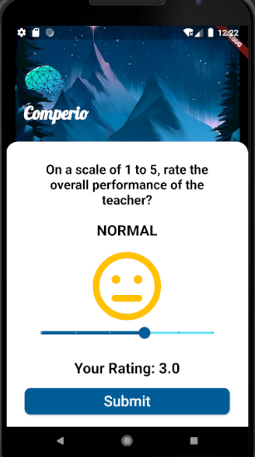

**Data Flow Diagram:**

Level 0 DFD

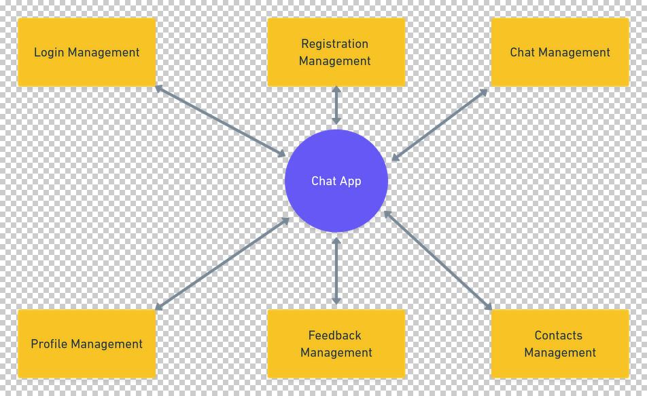

Level 1 DFD

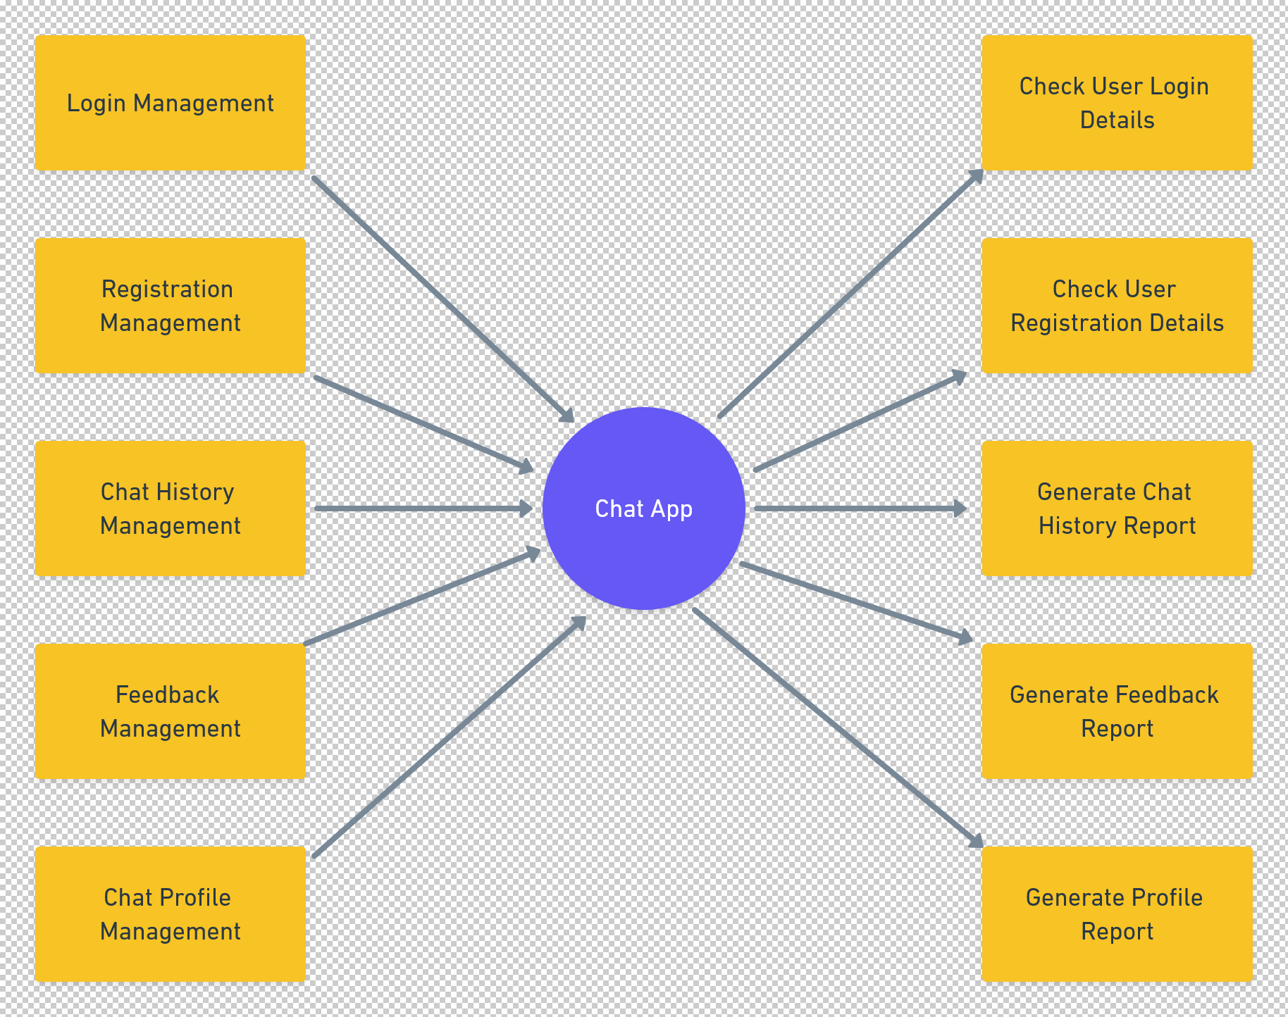

Level 2 DFD

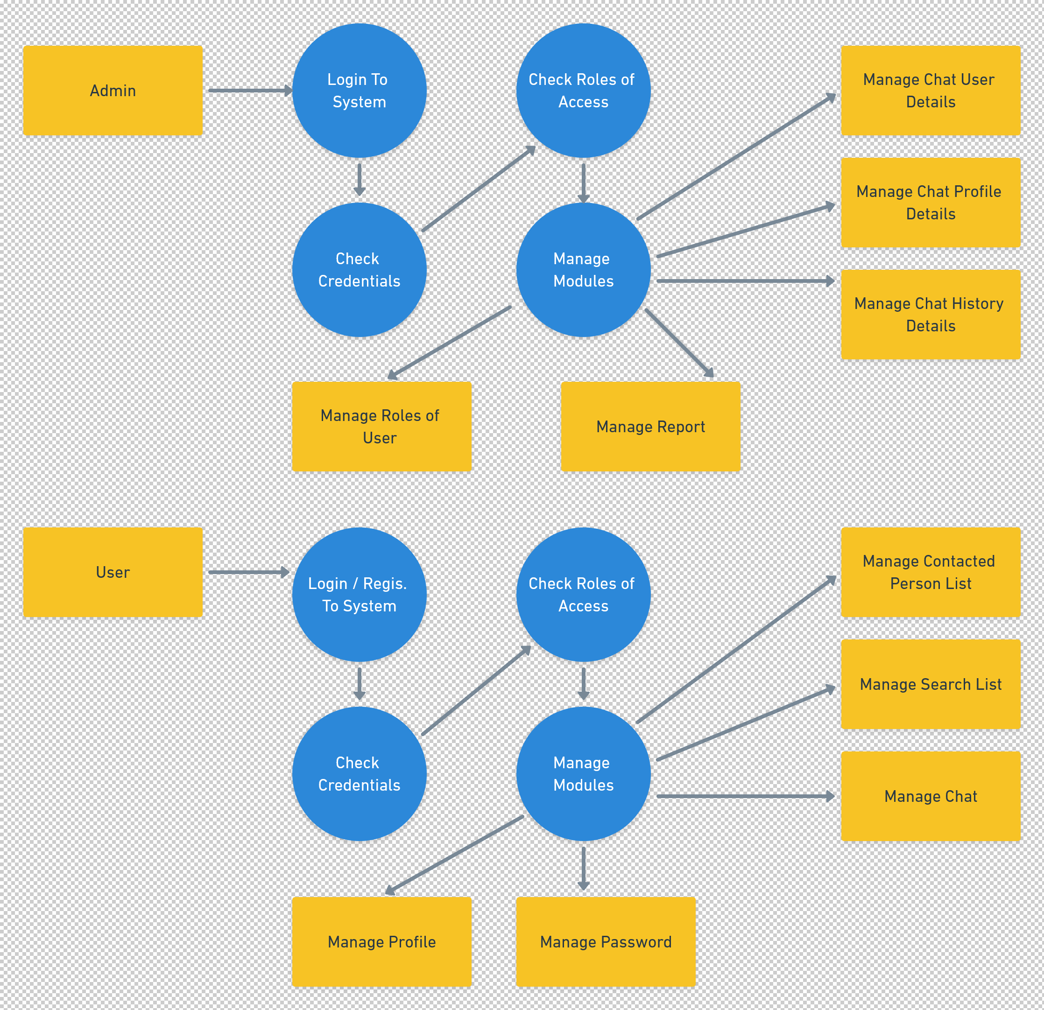

**ER Diagram:** 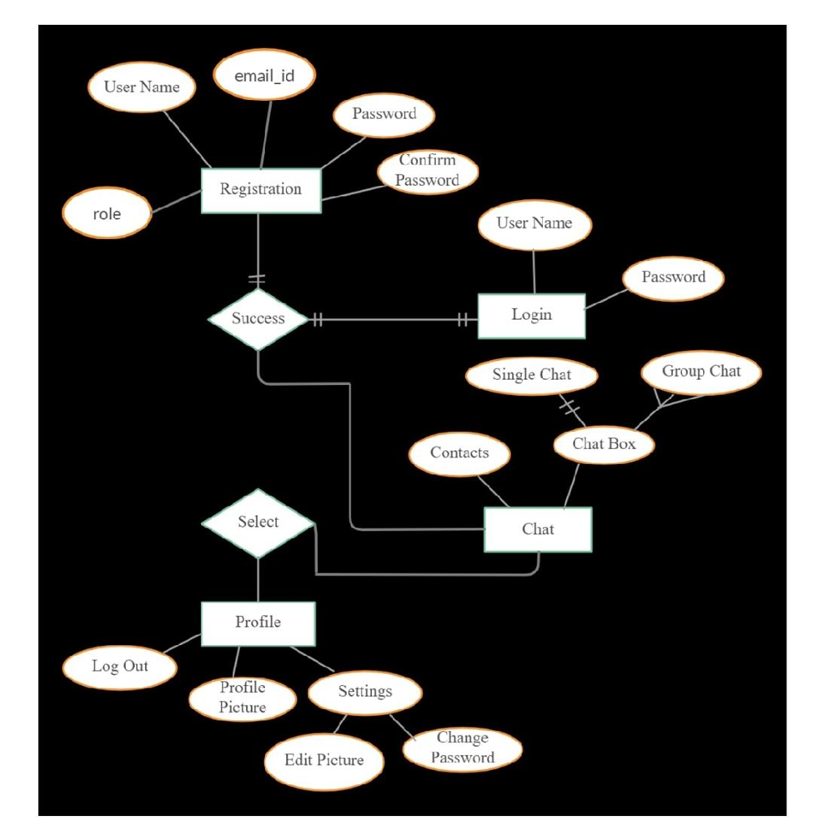

**Conclusion:**

From above discussion, it is evident how chat applications are purposed to play various roles in addition to acting as a chat communication medium.

The main objective of the project is to develop a Secure Chat Application. We had taken a wide range of literature review in order to achieve all the tasks, where we came to know about some of the products that are existing in the market. We made detailed research on that path to cover the loopholes that existing systems are facing and to eradicate them in our application. In the process of research, we came to know about the latest technologies and different algorithms.

**References**:

1. Reference for flutter documentation <https://flutter.dev/>.
2. About Android Studio <https://developer.android.com/studio>.
3. About Dart Language <https://dart.dev/>.
4. Some of the contents are from Internet.